MCHINJI DISTRICT MOCK EXAMINATIONS
2023 MALAWI SCHOOL CERTIFICATE OF EDUCATION MOCK EXAMINATION
PHYSICS
Friday, 24th March 2023 Subject Number M164/I
PAPER I Time allowed: 2 hours
(100 Marks)

Question Number | Tick if answered | Do not write in this columns
1
2
3
4
5
6
7
8
9
10
11
12
13
Instructions
- This paper contains 11 printed pages. Please check.
- Fill in your Name at the top of each page.
- This paper contains two sections A and B. in Section A there are ten short answer questions while in Section B there are four restricted essay questions.
- Answer all the 14 questions in the spaces provided.
- Use of electronic calculators is allowed.
- The maximum number of marks for each answer is indicated against each question.
- In the table provided on this page, tick against the number of the question you have answered.

©2023 mchinji

SECTION A (70 MARKS)
1. a. Define a semiconductor
________________________________________________________________________________________________________________________________________________________________________________________________________________________________(2 marks)
b. Figure 1 is a current –voltage characteristics graph for a forward and reverse biased diode. Study it and answer questions that follow:
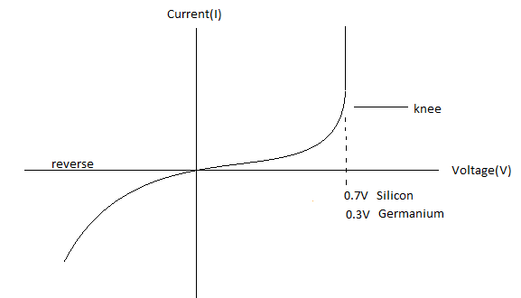
- Explain why the silicon and germanium have different voltages at the same knee point.
____________________________________________________________________________________________________________________________________________________________________________________________________________________________(2 marks)
- Explain the behavior of the diode in the reverse biased mode
____________________________________________________________________________________________________________________________________________________________________________________________________________________________(2 marks)
c. Mention any two environmental impacts of nuclear power generation
_________________________________________________________________________________________________________________________________________________ (2 marks)
d. Explain why the base of a dam is constructed thick.
____________________________________________________________________________________________________________________________________________________________________________________________________________________________________________________________________________________________________________(3 marks)
2. a. State Pascal’s principle
__________________________________________________________________________________________________________________________________________________ (1 marks)
b. Figure 2 is a hydraulic braking system. Study it and answer questions that follows
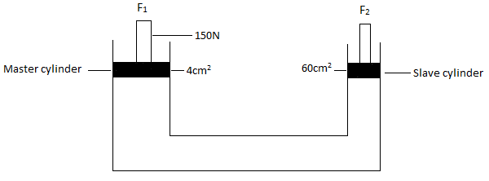
- Give two reasons why liquids are suitable in hydraulic system
______________________________________________________________________________________________________________________________________________(2 marks)
- Calculate the value of force (F₂) applied in the slave cylinder

- marks)
c. Mention any two applications of density
____________________________________________________________________________________________________________________________________________________________________________________________________________________________(2 marks)
3. a. Define Ohm’s law
_____________________________________________________________________________________________________________________________________________________________________________________________________________________________________________________________________________________________________________(2 marks)
b. Figure 3 is a circuit diagram, study it to answer questions that follows
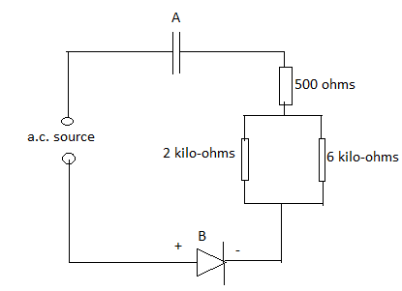
- Name the electronic component labeled A.
___________________________________________________________________ (1 mark)
- Mention any one use of the electronic component labeled B.
___________________________________________________________________ (1 mark)
- Calculate the effective resistance of the resistors

(3 marks)
c. Explain why identical resistor connected in series have higher resistance than when connected in parallel
________________________________________________________________________________________________________________________________________________________________________________________________________________________________________________________________________________________________________(2 marks)
d. Explain how cross-sectional area affect resistance
____________________________________________________________________________________________________________________________________________________________________________________________________________________________________________________________________________________________________________________________________________________________________________________(3 marks)
4. a. What is the difference between angular displacement and angular velocity?
_____________________________________________________________________________________________________________________________________________________________________________________________________________________________(2marks)
b. A bicycle wheel of radius 50cm is rotating about an axis at a frequency of 5Hz. Calculate the linear velocity of the wheel.

(3 marks)
c. Mention any two uses of frictional force
________________________________________________________________________________________________________________________________________________ (2 marks)
5. a. Define the term “bit”
_________________________________________________________________________________________________________________________________________________ (1 mark)
b. In terms of band theory, explain why a plastic does not conduct electricity
____________________________________________________________________________________________________________________________________________________________________________________________________________________________________________________________________________________________________________________________________________________________________________________(3 marks)
c. Mention any two differences between a human eye and a camera
____________________________________________________________________________________________________________________________________________________________________________________________________________________________(2 marks)
6. a. State Newtons second law of motion
________________________________________________________________________________________________________________________________________________________________________________________________________________________________(2 marks)
b. i. Calculate the amount of Force required to move a toy car of 8g mass accelerate at 6 m/s/s

(3 marks)
ii. Mention any one application of circular motion in everyday life
_________________________________________________________________ (1 mark)
7. a. State the law of conservation of linear momentum
_____________________________________________________________________________________________________________________________________________________________________________________________________________________________(1 mark)
b. A particle revolves at a frequency of 2 Hz in a circle of radius 2m. Calculate its centripetal acceleration

(3 marks)

c. Explain how mechanical advantage of an inclined plane can be increased.
____________________________________________________________________________________________________________________________________________________________________________________________________________________________________________________________________________________________________________________________________________________________________________________(3 marks)
8. a. Explain why tritium (${}_{1}^{3}H$) and deuterium (${}_{1}^{2}H$) are isotopes of Hydrogen
___________________________________________________________________________________________________________________________________________________ (1 mark)
b. Polonium (${}_{84}^{213}{Po}$) disintegrates to form Lead (Pb-209) and an alpha particle. Write down a
balanced nuclear equation.

____________________________________________________________________(3 marks)
c. What is the difference between induced and natural radioactivity?
________________________________________________________________________________________________________________________________________________________________________________________________________________________________________________________________________________________________________(2 marks)
9. a. State Faraday’s law
____________________________________________________________________________________________________________________________________________________________________________________________________________________________(2 marks)
b. Figure 4 is a diagram of a transformer. Study it and answer the questions that follows
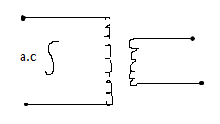
- What type of transformer is shown above?
___________________________________________________________________(1 mark)
- Mention any two ways how heat loss in the transformer can be minimized
____________________________________________________________________________________________________________________________________________________________________________________________________________________________(2 marks)
- State any two factors that affect magnitude of induced e.m.f in the device above.
_________________________________________________________________________________________________________________________________________________________________________________________________________________________ (2 marks)
SECTION B (30 MARKS)
Answer all questions
10. With the aid of a well labeled diagram, explain how a slide projector works

__________________________________________________________________________________________________________________________________________________________________________________________________________________________________________________________________________________________________________________________________________________________________________________________________________________________________________________________________________________________________________________________________________________________________________________________________________________________________________________________________________________________________________________________________________________________________________________________________________________________________________________________________________________________________________________________________________________________________________________________________________________________________(6 marks)
11. a. Define terminal velocity
_____________________________________________________________________________________________________________________________________________________________________________________________________________________________________________________________________________________________________________(1 marks)

b. With the aid of a well labeled graph, explain how a parachutist jumping from an airplane will
land?

____________________________________________________________________________________________________________________________________________________________________________________________________________________________________________________________________________________________________________________________________________________________________________________________________________________________________________________________________________________________________________________________________________________________________________________________________________________________________________________________________________________________________(5 marks)
- Explain how radioactivity is used to:
- Measure thickness of a material
______________________________________________________________________________________________________________________________________________________________________________________________________________________________________________________________________________________________________________________________________________________________________________________________________________________________________________(2 marks)
- Treat cancer
________________________________________________________________________________________________________________________________________________________________________________________________________________________________________________________________________________________________________________________________________________________________________________________________________________________________________(2 marks)
13. a. With the aid of a well labeled diagram, explain how an electric bell works.

____________________________________________________________________________________________________________________________________________________________________________________________________________________________________________________________________________________________________________________________________________________________________________________________________________________________________________________________________________________________________________________________________________________________________________________________________________________________________________________________________________________________________________________________________________________________________________________________________________________________________________________________________________________________________________________________________________________________________________________________________________________________________________________________________________________________________________________________________________________________________________(6 marks)
b. Explain how you can calibrate a spring balance.
___________________________________________________________________________________________________________________________________________________________________________________________________________________________________________________________________________________________________________________________________________________________________________________________________________________________________________________________________________________________________________________________________________________________________________________________________________________________________________________________________________________________________________________________________________________________________________________________________________________________________________________________________________________________________________________________________________________________________________________________________________________________________________________________________________________________________________________________________________________________________________________________________________________________________________________________________________________________________________________(5 marks)
c. Explain how different colours of the rainbow can be converted back to white light.

_____________________________________________________________________________________________________________________________________________________________________________________________________________________________________________________________________________________________________________________________________________________________________________________________________________________________________________________________________________________________________________________________________________________________________________________________________________________________________________________________________________________________________________________________________________________________________________________________________________________________________________________________________________________________________________________________________________________________________________________________________________________________________________________________________________________________________________________________________________________________(5 marks)

END OF QUESTION PAPER

